|  |
| --- |
| BUFF UP GAMES   |
| “Knight’s Best” |
| **A journey on the best quest.** |
| Version #1.0  All work Copyright © 2020 by Buff up Games.  All rights reserved. |
| **Amber Thompson** |
|  |

|  |
| --- |
| October 4th 2020 |

**Table of Contents**

1. Table of Contents

2. Health and Safety

3. The Story thus far…

4. Controls

5. Buff ups

**Version History**

* + - 1. .: 2020-10-03: Game Inception.

1.0.0.0 .: 2020-10-04(Live Release) Initial patch now with sound and sprites.

[This is the body of your video game design document. You should add and delete sections as they pertain to your game’s design.]

1. **Game Overview**

*(ensure you mention the goal of the game and how to win if applicable)*

*“Knight’s Best” Is a journey of heroism and valor. Purple Knight needs to slay the oncoming demons as he faces off in a seemingly never-ending gauntlet of life-threatening challenges, Impossible opponents and glorious conquest. Only once all enemies are slain may the Purple Knight achieve victory!*

1. **Game Play Mechanics**

Knight’s best is a vertical mobile gauntlet in which you play as Purple Knight, A glorious hero who fights waves of enemies with his buff sword. Destroy enemies with your swings and power yourself up with the buffs and healing items they sometimes drop. You’ll need them if you would dare challenge the multiple bosses ahead.

1. **Camera**

Top- Down, Vertical Orientation

1. **Controls**

This game is played using a virtual joystick and screen press- buttons.

1. **Interface Sketch**

1. **Menu and Screen Description**

Front page of “Knight’s Best” & “Game Over”

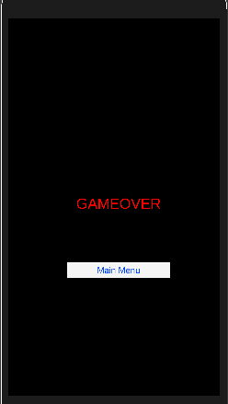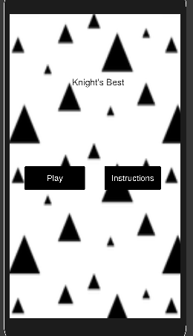

1. **Levels**

Level 1. Spider Den

Level 2. Oubliette

Level 3. BattleField

1. **Enemies**

Toxic Spiders

Savage Prisoners

Hungry Ogres

1. **Items**

Range Buff – Enables Projectile Sword Swings.

**Hearts – Heals by one heart point.**

1. **Abilities**

Projectile Sword Slash (Only available with range buff)

1. **Scoring**

You obtain points for slaying enemies and for every second you are not dead.

1. **Cheat Codes**

**Still In progress**

1. **Sound Index**

Aggrive

Death

LevelClear

Pickup

Range

Sunslammer BGM

The La2t Frontier BGM

1. **Art / Multimedia Index**

*Trianglewhite.png*

*Boss.png (unused)*

*Buff_Range.png*

*Enemy_Spider.png*

*Life.Png*

*LossLife.png*

*Player_Solider.png*

*Sprite-0001.png (unused)*

1. **Design Notes**

As this is the initial release we still have big plans for the continued development for this game. New fights, music and art to appreciate soon.

1. **Future Features**

*(Include any future features that are planned to be implemented)*